**Team Assignment 16**

**Author: Team 1.1**

**Version: Final**

**Table of Content**

1. Report Team’s Productivity
2. Update GQM models
3. Metrics
4. **Report Team’s Productivity**
5. **Define Metrics and Data collection**

|  |  |
| --- | --- |
| **Rule ID** | **Description** |
| R.01 | #Number of tasks = Number of team meetings + Number member tasks |
| R.02 | # Total actual time is described by hour, Total actual time = Actual time meeting + Actual time that member develops tasks |
| R.03 | Mark for Assignment team provided by Director |

Figure1. Table is described rules in data collection

|  |  |
| --- | --- |
| **Goals** | **Evaluate the productivity of team in one week** |
| **Question** | What is the workload that team developed in one week? |
| **Metric** | # number of tasks in one week |
| **Question** | What is the actual time (hour) completed all the tasks by team? |
| **Metric** | # Total actual time in one week |
| **Question** | How many will the average number of tasks completed in an hour? |
| **Metric** | # of tasks/ Total actual time in one week |
| **Question** | What is the value (mark) that team get after completing all tasks in one week? |
| **Metric** | # mark of team assignment |

Figure2. Productivity GQM table

|  |  |  |  |  |
| --- | --- | --- | --- | --- |
| **Required Data** | **Source** | **Rule** | **Periodic** | **Metrics** |
| # Number of tasks | Weekly Plan | R.01 | Weekly | Average # number of completed tasks in an hour |
| # Total actual time | Effort Log | R.02 | Daily |
| # Mark of assignment | Director | R.03 | Weekly | # Mark of team assignment |

Figure3. Data collection table

|  |  |  |  |  |
| --- | --- | --- | --- | --- |
| **Week ID** | **Number of detailed tasks** | **Workload** | **Time (hour)** | **Number of tasks/hour** |
| 8 | 4 Meeting + 19 Member task | 23 | 43 | 0.53 |
| 9 | 2 Meeting + 8 Member task | 10 | 18 | 0.55 |
| 10 | 0 Meeting + 0 Member task | 0 | 0 | 0 |
| 11 | 3 Meeting + 7 Member task | 9 | 18 | 0.5 |
| 12 | 4 Meeting + 8 member task | 12 | 29 | 0.41 |
| 13 | 3 Meeting + 12 member task | 15 | 28 | 0.53 |
| 14 | 3 Meeting + 9 member task | 12 | 39 | 0.3 |

Figure4. Number of tasks/hour table in Team Assignment 16

1. **Compare charts**

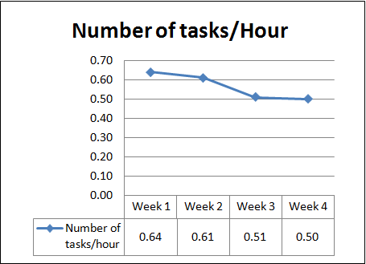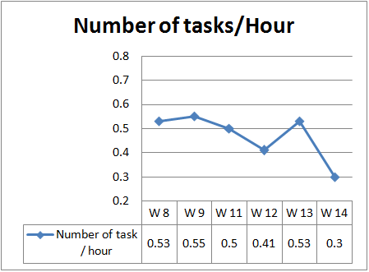

Status team’ productivity after week 8

Status team’s productivity before week 8

2.1 Evaluate current team’s productivity :

- In general: from to week 8 to week 14, team’s productivity has a decreasing trend. However, it has a slow increase over week:

+ From W8 to W9: increase from 0.53 to 0.55

+ From W12 to W13: increase from to 0.41 to 0.53. However, the productivity is still lower than that of W9 by 0.55

2.2. Compare Team’s Productivity before and after W8:

- Before W8: Highest productivity is 0.64. Lowest productivity is 0.5

- After W8: Highest productivity is 0.55. Lowest productivity is 0.3

- Evaluation: Team’s productivity is decreasing and below 0.5

2.3 Evaluate the effectiveness of the improvements:

- The improvements are ineffective in the following issues:

+ Working attitude

+ Team spirit

+ Communication

*Reason analysis:*

- Listening skills are not good

- Team members’ relationship network is getting more conflicts

- Some individual did not fulfill their tasks. This results in the lateness for deadline of the whole team assignment

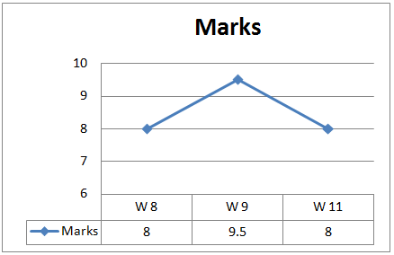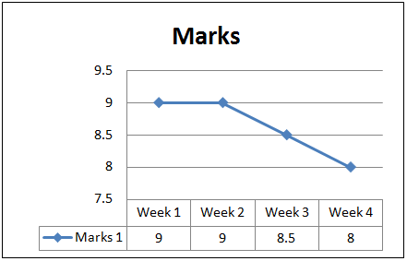

Evaluation:

- The results are all above 8, which satisfies team’s target.

- All of the results fluctuate within the range from 8 to 9.5.

1. **Update GQM models**

After this course, we think that when we make to resolve a goal. They are two things that we must think:

1. Identify steps to accomplish goals
2. What is the end result that

We think that there are two measurements when we resolve a goal:

1. Measured steps to accomplish successful or not
2. Measure goal is completed or not

When we build GQM method for goal “Reduce product schedule by 10%”, we focus on building steps to accomplish goal and methods to measure identity successful or not but we forger measure goal is completed or not. This is important mistake.

So following this exercise, we propose to complement for team assignment #4:

* Identify standard for steps
* Complement formula for “Initial project schedule versus actual schedule” metric

M1= (Actual Schedule – Planed Schedule)/Planed Schedule

If M1 >= 10% achieved goal

1. **Metrics**
2. **Schedule**

|  |  |  |  |  |
| --- | --- | --- | --- | --- |
| **Metric Name** | **Require Data** | **Objective** | **Strength** | **Weakness** |
| Measure Logic | Schedule | - Is all required work included in the schedule?  - Does the schedule achieve the project’s definition of: done, quality, success? | Testing and Ensure the schedule of project clearly |  |
| Measure Estimation | Schedule | - Are task, work and duration estimate viable?  - Are Budget estimate viable? | Testing and ensure the schedule of project clearly |  |
| Measure Technical | Schedule | - Audit tasks, resource, schedule, and calendar | Find any error in tasks, resource, schedule and calendar |  |

1. **Budget**

|  |  |  |  |  |
| --- | --- | --- | --- | --- |
| **Metric Name** | **Require Data** | **Objective** | **Strength** | **Weakness** |
| Return on Investment | - Total benefits  - Total cost | - ROI is used to calculate the ROI for our project | Testing and Ensure the schedule of project clearly | This indicator is a long time to wait for payback and ignores the time value of money. |
| Payback period | - Total Cost  - Annual $ Saved | - PP is used to calculate the pay- back period of our product | Testing and ensure the schedule of project clearly | This indicator is a long time to wait for payback and ignores the time value of money. |
| Breakeven analysis | - Fixed costs  - Revenue per unit  - Variable cost per unit | - BA is used to analysis breakeven | Find any error in tasks, resource, schedule and calendar | It’s very hard to calculate exactly fixed Cost |
| Internal rate of return | - Cash flow in time | - Is a [rate of return](http://en.wikipedia.org/wiki/Rate_of_return) used in [capital budgeting](http://en.wikipedia.org/wiki/Capital_budgeting) to measure and compare the [profitability](http://en.wikipedia.org/wiki/Profit_%28economics%29) of [investments](http://en.wikipedia.org/wiki/Investment) | Analyze and evaluate budget of project relatively |  |
| Net Present Value | - Cash flow in time  - PVIF | - Used to evaluate future cash flows less any initial investment costs and compare to choose one in more projects | Analyze and evaluate budget of project relatively | In many case, IRR is not as effective as ROI |

1. **Earned Value**

|  |  |  |  |  |
| --- | --- | --- | --- | --- |
| **Metric Name** | **Require Data** | **Objective** | **Strength** | **Weakness** |
| Cost Variance ( CV ) | - BCWP  - ACWP | - Using to calculate deviation Cost about Actual and Plan. | Using EVM, a project manager can track project progress accurately and objectively by comparing how much work has actually been completed against the amount of work planned. Its enables consistent tracking of project progress across portfolios of projects and predict of project completion. | Weakness of EVM is very hard to implement on small project. EVM expect a lot from effort’s team development and invest much time and energy in collect and evaluate data. |
| Schedule Variance ( SV ) | - BCWP  - BCWS | - Using calculate deviation schedule about Actual and Plan. |
| Cost Performance Index ( CPI ) | - BCWP  - ACWP | - Using to calculate Cost Actual / Plan Rate |
| Schedule Performance Index ( SPI ) | - BCWP  - BCWS | - Using to calculate Schedule Actual / Plan Rate |
| Variance at Completion (VAC) | - BAC  - EAC | - Using to calculate deviation Cost about Actual and Plan at completion |
| Estimate at Completion (EAC) | - BCWS  - CPI | - Using to predictive Budget at completion |
| Independent Estimate at Completion | - BAC  - CPI | - Using to predictive Budget at completion in times |

1. **Risk**

|  |  |  |  |  |
| --- | --- | --- | --- | --- |
| **Metric Name** | **Require Data** | **Objective** | **Strength** | **Weakness** |
| Risk Explore | - Probability of loss  - Size of loss | Using to calculate explore of each risk | Help us define each risk’s impact and we have action to solve. Sum all schedule RE’s to get expected schedule overrun. | Don’t provide accurately forecast. |
| Risk Score | P(Probability)  I (Impact ) | Using to calculate | The metric helps we can priority risk. If risk has high risk score, we will solve first | Many risk will common Score, we will choose very hard. |

1. **Quality**

|  |  |  |  |  |
| --- | --- | --- | --- | --- |
| **Metric Name** | **Require Data** | **Objective** | **Strength** | **Weakness** |
| Defect Severity Index | - Total number of defect weekly  - Number of defect by severity  - Defect Severity Score | An index representing the average of the severity of the defects. | Provides a direct measurement of the quality of the product | Difficult to accurate reflect the severity of the defects |
| Defect Removal Efficiency | - Defects removed during a development phase  - Defects latent in the product at that phase | Indicates the efficiency of defect removal methods, as well as. | Provides indirect measurement of the quality of the product | Difficult to know which step of the process problems |
| Defect Removal Effort | - Average time to fix a defect by severity | Indicates the efficiency of defect removal methods | Good for defects that is in house | Depending on the process that use remove defect and developer's ability |

1. **Productivity**

|  |  |  |  |  |
| --- | --- | --- | --- | --- |
| **Metric Name** | **Require Data** | **Objective** | **Strength** | **Weakness** |
| Productivity Index | - Number of tasks in one week  - Total actual time in one week | To determine the productivity of team | Alignment with the workload of team in a week | Difficulty of work reflect to workload of team in a week |

1. **Team Morale**

|  |  |  |  |  |
| --- | --- | --- | --- | --- |
| **Metric Name** | **Require Data** | **Objective** | **Strength** | **Weakness** |
| Employee Satisfaction Index | - Total % positive of key aspects  - Number of key aspects | Calculates employee satisfaction index | Reflects the total of employee satisfaction | Difficult to reflect the individual employee satisfaction |